This file will have imformation about Linux file structure.

- Linux is a open source and free operationg system.

As mentioned it is an open source this means the kernal code can be accessable easily for all time and its opern for all. (Kernal is the programm that helps to communicate between hardware and software.)

As the kernal code is open so anyone can take it and edit it and can have their own operating system
which may be replica of linux.

As a result of this we can see their are 3K and above flavours of linux like Ubantu , Redhat, CentOS, debian and many more. This operting systems my have different different UI and UX and may have different functunalities based on theire significance but not that the base of all this OS are
upon Linux only.

- 2. Why linux is different than windows?

There are hundreds of way that we can differenciates between Linux and Windows , but here we are going differenciate opon file structure in both.

Types of users

In Linux there are ony 3 user that are Regular, Adminitrator(root), and Service
(Root user have all previlages )

Regular user is the general account that is created for you for general work purpose. And all of your files are stored in root/home/ .

If you are one user then you cant access the files and deirerctories of other user.

Root user other than regular user there is one more user is created while installation this called root user.

It also called as superuser who can access all restriced files and can install programmes, and can have all the prvillages that admistrator have.

Example

In windows to do an administration task we must log in as as admin account.

But here in linux its not neccessry that to login as a root user , we can directly have previllages like Root user using (sudo command) but after this it will promt for the root password.

Types of files

whole linux is differnciates betwn files and dirctories . Directories are just like folders in windows.

In windows the file structure is based on My computer – C: D: E: etc.

Then the partiotioned drive we can use for our convenience. And whenever ther new user is created it is in C: and files are kept in C:

But in Linux its differnet in fact we can say that the whole file structure is different than windows.

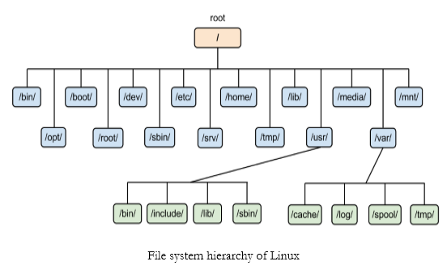

Root is the king of whole file structure. As seen the whole files directories and users data all are under root.

As seen under the root there are many subdirectories like.

/home
/usr
/etc
/dev
/tem
/var
/boot

- /dev ---contains special devices files which are used by system to access the hardwares.
- /etc – contains sytem configuration file
- /home – whenever new user is created it under the home directory home directory keeps the file and directories of all general users.

- /usr – installed softwares and packges are keep under the /usr
/usr/bin contains all the commands that which can executeable by general user
/usr/sbin contains all the commands which can only be exucuted by root.
- /boot – file which are required to boot the linux

Paths in Linux System

There are 2 paths is linux file systems

1 Relative path
2 Absolute path

Relative path suppose we are working as user in /home/pawan

and we want to go to /home/pawan/sql/imp

so we did not need to mention complete path line /home/pawan/sql/imp

simply we can use cd imp

because we are in same directory this is called relative path.

Absolute path

suppose we are working as user in /home/pawan

and we want to access /home/aloha/python/bugs so here we need to mention the complete path becuase the taargeted path is under different user so we cant directly accees it .

This is called absolute path.

